**IT5613**

**Socially relevant project laboratory**

**Batch – 2**

**Team – 4**

**Flood Prediction System**

**Team members**

Abinesh R (2021506004)

Marimuthu Thrisha Devi (2021506048)

Niranjana J (2021506057)

Shylesh V R (2021506100)

**Flood Prediction**

Floods, as natural calamities, pose significant threats to both human lives and the environment, often resulting in widespread devastation and loss. This project is essential due to the increasing frequency and intensity of flooding events globally by factors such as climate change, urbanization, and deforestation. With floods causing extensive damage to infrastructure, agriculture, and human lives, there is a critical need for proactive measures to mitigate their impact. By developing an advanced flood prediction system, we can provide early warnings, enable effective evacuation planning, and implement timely flood management strategies, ultimately saving lives and reducing the socio-economic consequences of these devastating events.

The project aims to develop a web-based system that utilizes machine learning algorithms and real-time data inputs to predict the likelihood and magnitude of floods in specific regions. The system will include features such as predictive modelling and alert mechanisms to provide timely information to the public users. The project is divided into multiple modules as stated below:

* **Data Collection and Processing:** Gathering and preprocessing of relevant data sources, including weather forecasts, river levels and historical flood data.
* **Predictive Modelling:** Development and training of machine learning models to analyse patterns and trends in the data and generate flood forecasts.
* **User Interface:** Creation of an intuitive web-based interface for users to access flood predictions, view interactive maps, and receive alerts and notifications.
* **Alert System:** Implementation of automated alert mechanisms to notify authorities and residents of areas at risk of flooding, based on the predicted severity and timing of events.

The system will be developed using Python for its support of libraries focused on data analysis and machine learning, we will be using TensorFlow, Scikit-learn and pandas to be specific. The web application will be built using HTML5, CSS3 and JavaScript for the frontend development and Flask for the backend. The database application selected for our system is PostgreSQL for its advance features such as spatial extensions. This combination of development tools will help us to create a user-friendly interface with powerful functionality.

In our flood prediction project, the repository will consist of various entities that organize and manage the data required for flood prediction and visualization. These entities will include:

**Weather Data:** This entity will store historical weather data as well as real-time weather updates obtained from meteorological sources or APIs. Parameters such as temperature, precipitation, humidity, wind speed, and atmospheric pressure will be recorded at regular intervals and used as input for flood prediction models.

**Hydrological Data:** This entity will contain data related to water levels, flow rates, and other hydrological parameters of rivers, streams, and other water bodies. Information from river gauges, streamflow measurements, and hydrological models will be stored to assess the current state of water bodies and predict potential flooding.

**Flood Event Data:** Historical records of past flood events will be stored in this entity, including details such as the location, severity, duration, and impacts of previous floods. Analysing past flood events can provide insights into patterns and trends, helping to improve the accuracy of flood prediction models.

**Model Parameters and Results:** This entity will store the parameters and results of the flood prediction models developed as part of the project. Parameters such as model coefficients, training data, and validation metrics will be saved, along with the predicted flood risk levels for different areas.

**User Accounts and Preferences:** For user interaction, a repository entity will be dedicated to storing user accounts, preferences, and settings. Users can create accounts to customize their flood risk notifications, favourite locations, and other preferences within the system.

**Administrative Logs and Reports:** This entity will maintain logs of system activities, user interactions, and administrative actions. Additionally, reports summarizing flood prediction results, system performance metrics, and user feedback will be stored for monitoring and evaluation purposes.

**Architecture Diagram**

The architecture for the proposed flood prediction system can be described as given below:

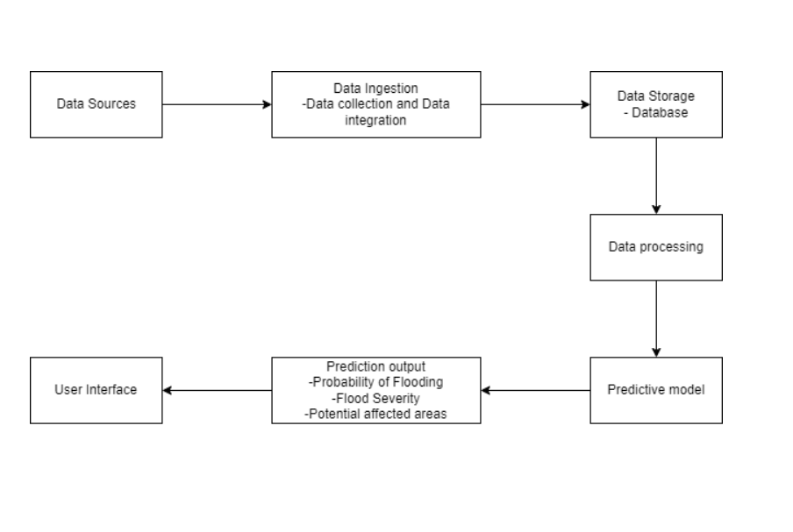

**Dataset Link:**  
https://www.earthdata.nasa.gov/learn/pathfinders/disasters/floods-data-pathfinder/find-data